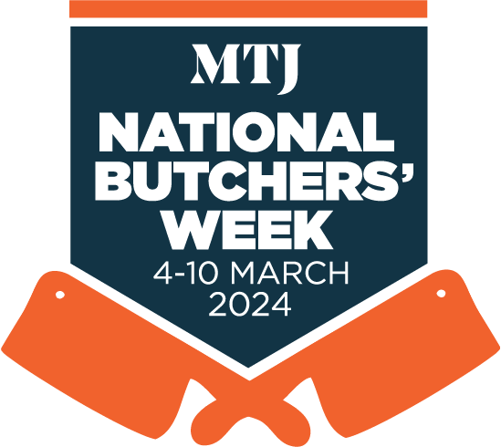

INSERT DATE HERE

WRITE A HEADLINE – KEEP IT SIMPLE
EG: LOCAL BUTCHER LAUNCHES ONLINE MEAT MASTERCLASS FOR NATIONAL BUTCHERS’ WEEK

WRITE A CONCISE FIRST PARAGRAPH THAT SUMMARISES YOUR STORY:
Eg: (name of your town) butcher (name of your shop) is holding a series of ‘meat masterclasses’ at its store in (name of street or part of town/city) during National Butchers’ Week, which takes place from March 4-10..

CONTINUE TELLING YOUR STORY:
Eg: Master butcher (insert name, eg: John Smith) will be holding demonstrations at online at 2pm each day from Monday March 4, helping customers to understand more about different cuts of meat and how they can be cooked.

John will be using the National Butchers’ Week masterclasses to share the knowledge he has gleaned about meat during more than 20 years working as a butcher.

INSERT A QUOTE THAT EXPLAINS WHAT YOU ARE DOING AND WHY:
Eg: “National Butchers’ Week is a great opportunity for us to bang the drum for the local butcher and remind people that we are here to help,” says John.

“Your local butcher has knowledge about meat that you won’t find anywhere else. We want to encourage people to tap into that knowledge, learn more about meat and, most importantly of all, learn how to cook it and enjoy it at home.”

ENDS

Note to Editors:
National Butchers’ Week takes place from March 4-10. The event is organised by William Reed.

For more information:
Contact (name of shop contact) on (telephone number) and at (email address)

WHAT TO DO NEXT:

- Once you have written your press release, give it to someone else to read so that you are sure it makes sense, and make sure you have included the key details that are essential in all good press releases – WHO you are, WHAT you are doing, WHEN you are doing it, WHERE you are doing it, and WHY you are doing it.
- Send your press release (and image, if applicable) to the news desk at your local newspaper(s), radio station etc. – preferably by email, but it’s also alright to send the information by post.
- If you are holding an online event during National Butchers’ Week, then send your press release to your local media one to two weeks before the event takes place, so that they can plan it into their news schedule.
- If you are sending out a release after National Butchers’ Week – to tell them about an event or initiative that took place at your shop – then try to do so as soon after the event as possible. There is nothing to stop you sending different press releases out to media both before and after your event takes place.
- Give the news desk a ring to tell them that you have sent them some information and quickly tell them what the story is about. Ask if they need any more information.
- Your local newspapers are likely to list contact details for the news desk in each edition. If you are stuck, get in touch with the MTJ team on 01293 846608.

